Data Model Description
This Data model has been created by keeping in mind the clients’ requirements for their business which is the company that import a range of different speciality Cheeses from France and the Netherlands. They supply the cheese to several different restaurants and specialist delicatessens throughout the UK but the challenge they face more often is that due to currency exchange rate fluctuations (between the Euro, that they buy the cheese in, and the pound that they sell it in) and the variations in economic growth changes in the following Cheese importing companies as well as in UK economic growth. As the company has mentioned that they sell Cheese Expensively well when the Economic growth is well and poor when it’s not.

So, coming to this Data model Design and function it is has been created for the company so that when the Economic growth is stumbling down or rising up the data model gives them all the alternate predicated profits that the company is going to make or if the company is going to face any losses due to the price fluctuations between the Euro, that they buy the cheese in, and the pound that they sell it in.

Well, of course to analyse all the data can be quite Difficult but there are also graphical representation features added to the data model, so it makes easier for the company fetch the data in the form of Visual Graphics. The user interface has also been created as the “Home Page” with the buttons that takes the user effortlessly to any sheet created in the Data Model.

- Story Boards

Final User Interface Design
Image3
Image2
Image4
Image1
Text
Button4(Text)
Button3(Text)
Button2 (Text)
Image Logo

Button1 (Text)

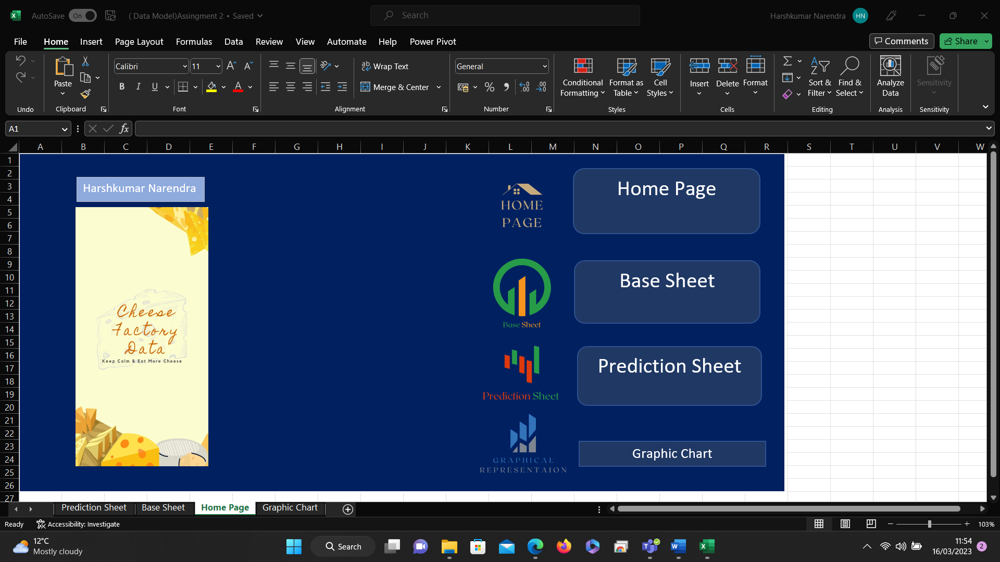

Justification for Final Design:
This Design has been chosen keeping in the mind several things from which first most is that as buttons which are linked with the data sheets have been kept at the left most side which leaves more space in the middle of the interface so that if in case the clients ask for any extra features for which there needs to be more separate data sheets. So, for those sheets’ buttons can be added in the middle of the interface. Also, as it can be seen their that the User Interface looks simpler and clean which makes it easier for the clients to navigate through the Data Model. There were several other alternate ideas as well for the user interface which have been mentioned below.

- Alternate Design 1:
Text
Date
Interface Title
(Text)

Image2
Image1

Image3
Button2
Button1
Button3
- Alternate Design 2:

Date
Name
Image1
Button1
Image

Image2
Button2
Image3
Button3

Flow Chart
In this sheet the company can see the data with visual representation which will show amount of profit or loss made by them.
In this prediction sheet the company can calculate alternate profits/loss the company may suffer.
In these Base sheets the data can be added, this will be the sheet where total profit /loss can also be seen.
For graphical representation press the Chart button

For Data Entry into actual sheet click on Base Sheet button
Every Data Sheet has a “Home Page” button which navigates the user back to the home page sheet again.
Worksheet structure diagram

Input:
FIELD NAME | DATA TYPE | VALIDATION (IF ANY) | FORMATTING (IF ANY) | SAMPLE DATA | DESCRIPTION OF THE FIELD
Cheese | Text | Text only field!!  Character should be only between 4 to 9 characters!! | None | Camembert | Shows the name of the cheese between 4 character & 9
Cost per Kilo in Euros | Currency | None | Number to Currency | €28 | Shows amount in euros
Average monthly sales based on Euro to Pound exchange rate of 0.7 | Numbers | None | “IF” function has been used in this field (=IF ($B$11=0.1, 'Base Sheet ‘! C2-20, 'Base Sheet '!C2)) | =900  If the increment is above or equal to 0.1 sells are decreased by 20 products and products sell becomes  =880 | This field shows that if the increment does increase by 10P every time sales are decreased by 20 products.

Output:
FIELD NAME | DATA TYPE | VALIDATION (IF ANY) | FORMATTING (IF ANY) | SAMPLE DATA | DESCRIPTION OF THE FIELD
Selling Price in GBP | Calculations/Currency | None | Absolute Referencing has been used in this field | Absolute Referencing in Field D2:  B13= 40%  =(E2*$B$13)+E2  =£27.44 | When you multiply your Cost in GBP to 40% margin and add the cost again it gives you selling price GBP.
Cost in GBP | Calculations /Currency | None | Absolute Referencing has been used in this field as well | Absolute Referencing in Field E2:  B12= 0.7  =B2*$B$12  =£19.60 | When you multiply the Price in Euro to 0.7 Exchange rate it gives you Cost in GBP
Profit Margin | Calculations /Currency | None | Absolute Referencing has been used in this field. | Absolute Referencing in Field F2:  B13= 40%  =E2*$B$13  =£7.84 | When you multiply your Cost in GBP to 40% margin it gives you profit margin.
Profit in GBP | Calculations /Currency | None | Subtraction & multiplication has been used in this field. | Calculation Formula in field  G2:  =(D2-E2) *C2  =£6,899.20 | When you subtract cost in GBP from Selling price in GBP and multiply it by products sold it gives you total profit.

Test Plan

Test No. | Description | Purpose | Expected result | Actual result | Action Taken
1 | Checking the button on GUI | To check if the buttons are working as expected on GUI | If I click on ‘Base Sheet’ & ‘Prediction Sheet’ then Base Sheet page & Prediction Sheet should open | Base Sheet & Prediction Sheet page opened when I clicked on button | None
2 | Images Inserted | To check if images are displayed on the User Interface | Images should be displayed on Homepage | All images are displayed on the Homepage | None
3 | Validation Testing | Checking if the Cheese column accepts any value or character beyond the stated range. | If I enter a value which doesn’t fit in the stated range, then I should get an error | I got an error message while entering data character more than 4 or equal to 9 in this field. | None
4 | Error handling | I tried to enter test data ‘In the Cheese name field in which is I kept number first it has shown error also I tried to put more character than 9 or less than 3 but it has shown necessary errors. | If I enter number type of values in text field or if I insert more characters, it shows throw an error. | I had error when I tried to enter ‘camemberts’ in the Cheese field | None
5 | Calculation check | Checking if =IF ($B$11=0.1, 'Base Sheet '!C2-20, 'Base Sheet '!C2) is giving the correct result. | Expected output of =IF ($B$11=0.1, 'Base Sheet '!C2-20, 'Base Sheet '!C2)) should be 880 | It shows the value 880 | None
6 | Layout check | If the Homepage GUI is matching with the  storyboard | Homepage GUI should match with the storyboard | Homepage GUI is matching with the Storyboard. | None

